Infonique

iSEB Expansion Board 1200 0012 V1.4

|  |  |  |
| --- | --- | --- |
| Prepared by | Date | Version |
| Bing Ran | 28/03/2024 | 1.4 |

# Abstract

This document provides detailed of Infonique iSEB Expansion Board 1200 0012 V1.1 specification.

# Document History

|  |  |  |  |
| --- | --- | --- | --- |
| **Date** | **Rev** | **Modifier** | **Changes** |
| **15-July-2023** | 1.0 | Bing Ran | First Draft |
| **10-Sept-2023** | 1.1 | Bing Ran | Further elaboratoin about WiFi and servo motor |
| **06-Oct-2023** | 1.2 | Bing Ran | Further elaboratoin & update naming |
| **17-Dec-2023** | 1.3 | Bing Ran | Update Board schematic |
| **28-March-2024** | 1.4 | Bing Ran | Update merus and walking figure |

# Contents

Abstract 2

Document History 2

Contents 3

1 Introduction 6

2 Hardware 7

2.1 Schematic 7

2.2 Pinout 8

2.2 PCB Layout 9

2.2.1 Label of legs 10

2.2.2 PWM control 11

2.2.2.1 PWM Control Servo Motor Connection 11

2.2.3 Battery Connector & RGB Led 13

2.2.4 Switch 14

2.2.5 MT3608 step-up converter 15

2.2.5 Buzzer 16

2.2.6 TP4056 module 17

2.2.7 Capacitor and resistor 18

2.3 Bom list 18

3 Firmware 19

3.1 Specification of the ESP32 DevKit V1 19

3.2 Environment set up 20

3.3 WiFi 24

3.3.1 How the WiFi Code works 24

3.3.2 WiFi server and control UI 25

3.4 Servo Motor 30

3.4.1 How the Servo Motor Code works 31

3.4.1.1 Setup 31

3.4.1.2 Code of motorInit function 32

3.4.1.3 Update duty cycle during runtime 33

3.4.1.4 Set_PWM_to_Servo 33

Table of Figures

Figure 1: Robot that controlled by iSEB Expansion Board 1200 0012 V1.0. 6

Figure 2: Schemaitc of iSEB Expansion Board 1200 0012 V1.2 7

Figure 3: iSEB Expansion Board 1200 0012 V1.0 without ESP32 Module 9

Figure 4: iSEB Expansion Board 1200 0012 V1.0 with ESP32 Module 9

Figure 5: Classification of Walking and Merus legs 10

Figure 6: PWM control port 11

Figure 7: SMLab iCrab’s Merus legs 12

Figure 8: SMLab iCrab’s Walking legs 12

Figure 9: Battery connector & RGB led 13

Figure 10: Battery Switch 14

Figure 11: MT3608 Step-up Converter circuit 15

Figure 12: Schematic of MT3608 step up converter 15

Figure 13: Buzzer 16

Figure 14: TP4056 Module 17

Figure 15: Capacitor and resistor 18

Figure 16: Pinout of ESP32 DevKit V1 19

Figure 17: File -> Preferences and click on the icon 20

Figure 18: Adding board manager URLS 20

Figure 19: Install ESp32 by Espressif Systems at Board Managers 21

Figure 20: Instal WS2812FX library 21

Figure 21: Upload setting 22

Figure 22: Compile and upload 23

Figure 23: WiFi List 25

Figure 24: Access ISEB Crab through web broswer 25

Figure 25: Control Page 26

Figure 26: Motion Editor Page 27

Figure 27: Zero Page 28

Figure 28: setting page 29

Figure 29: How servo’s position controlled by PWM signal 30

Index of Tables

Table 1: Pinout 7

Table 2: Position vs GPIO vs Channel vs Connector matrix 31

# 1 Introduction

This document will discuss the details of the iSEB Expansion Board 1200 0012 V1.0. iSEB Expansion Board 1200 0012 V1.0 is design for a SMLab iCrab robot. It provide 8 rgb leds (red green blue leds ) and 16 pwm output to control the servo motors. The following figure is one of the robot that control with iSEB Expansion Board 1200 0012 V1.0.

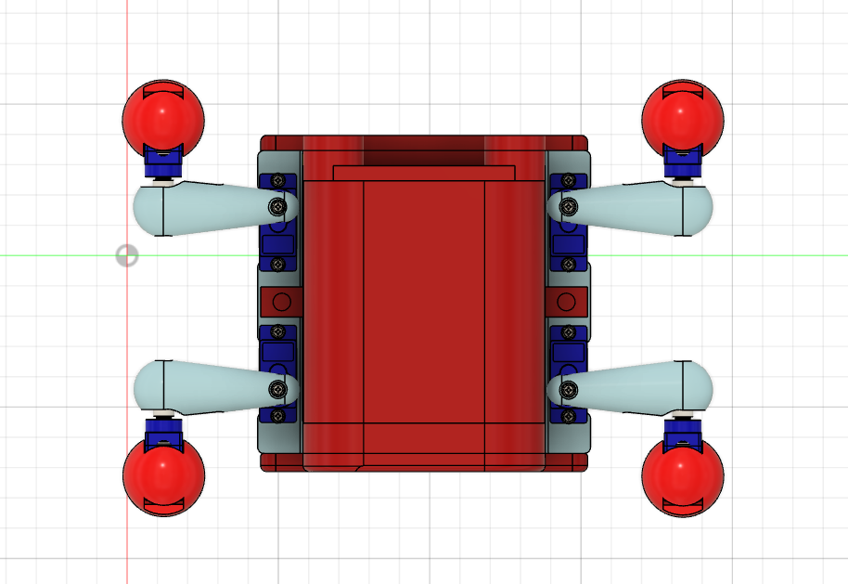

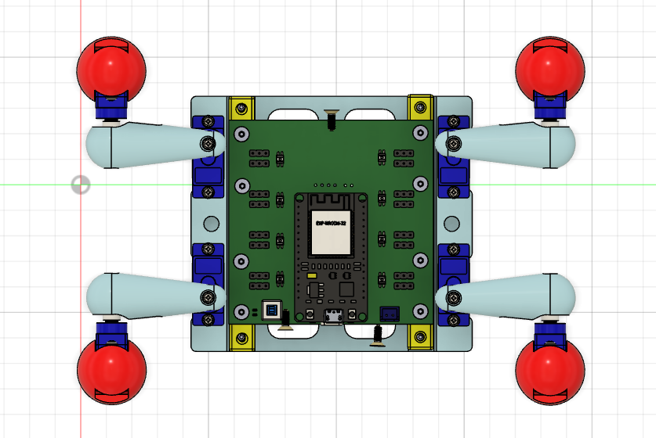Figure 1: Robot that controlled by iSEB Expansion Board 1200 0012 V1.0.

# 2 Hardware

## 2.1 Schematic

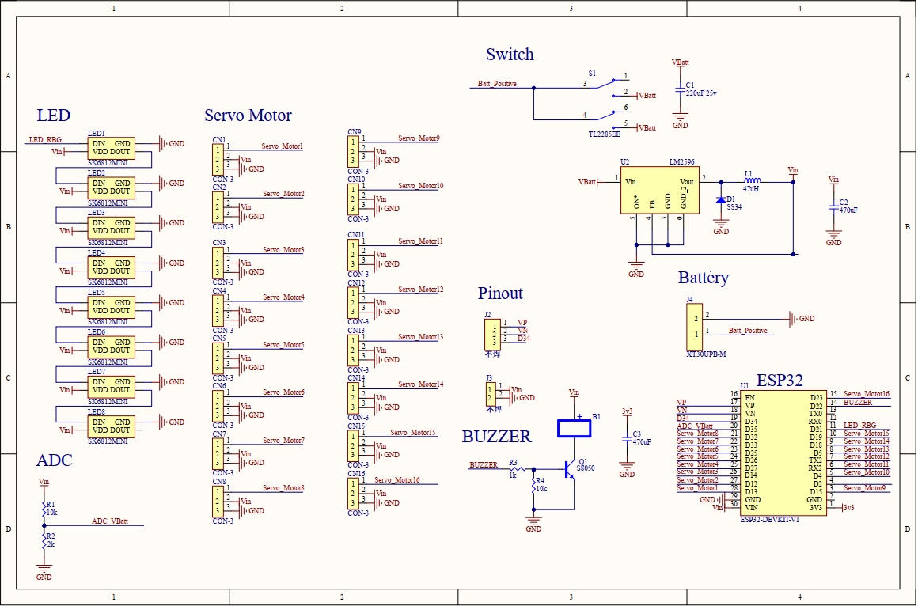

Figure 2: Schemaitc of iSEB Expansion Board 1200 0012 V1.3

## 2.2 Pinout

|  |  |  |  |
| --- | --- | --- | --- |
| **Pin** | **Function** | **Pin** | **Function** |
| EN | Enable Pin | D23 | PWM16 |
| VP | Unused | D22 | Buzzer |
| VN | Unused | TX0 | TX0 |
| D34 | Unused | RX0 | RX0 |
| D35 | ADC Vbatt | D21 | RGB Led |
| D32 | PWM8 | D19 | PWM15 |
| D33 | PWM7 | D18 | PWM14 |
| D25 | PWM6 | D05 | PWM13 |
| D26 | PWM5 | D17 | PWM12 |
| D27 | PWM4 | D16 | PWM11 |
| D14 | PWM3 | D04 | PWM10 |
| D12 | PWM2 | D02 | None |
| D13 | PWM1 | D15 | PWM9 |

Table 1: Pinout

## 2.2 PCB Layout

The following is the figure of the iSEB Expansion Board 1200 0012 V1.0

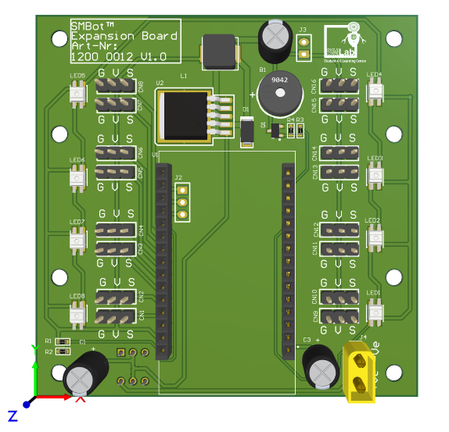

Figure 3: iSEB Expansion Board 1200 0012 V1.0 without ESP32 Module

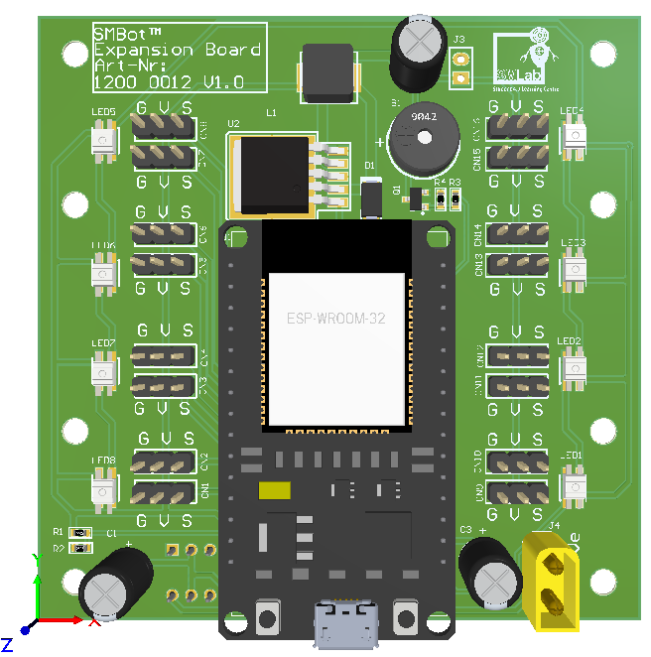

Figure 4: iSEB Expansion Board 1200 0012 V1.0 with ESP32 Module

### 2.2.1 Label of legs

The following figure is labeling the legs of the SMLab iCrab.

Figure 5: Classification of Walking and Merus legs

## 

### 2.2.2 PWM control

There are 16 PWM control port in iSEB Expansion Board 1200 0012 V1.0. The figure below is showing the locaiton of the 16 PWM control port.

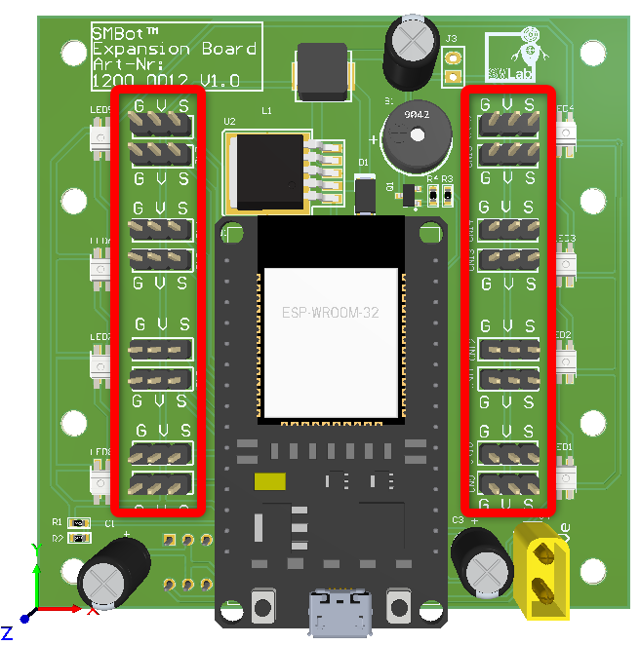

Figure 6: PWM control port

#### 2.2.2.1 PWM Control Servo Motor Connection

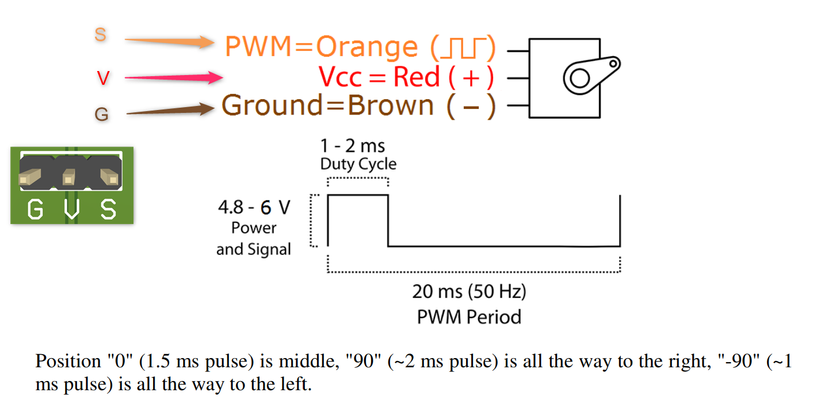

The figure below is specifying the port for each SMLab iCrab’s merus legs.

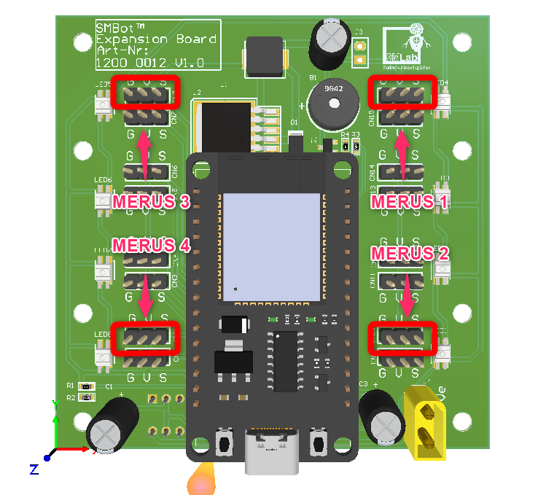Figure 7: SMLab iCrab’s Merus legs

The figure below is specifying the port for each SMLab iCrab walking leg.

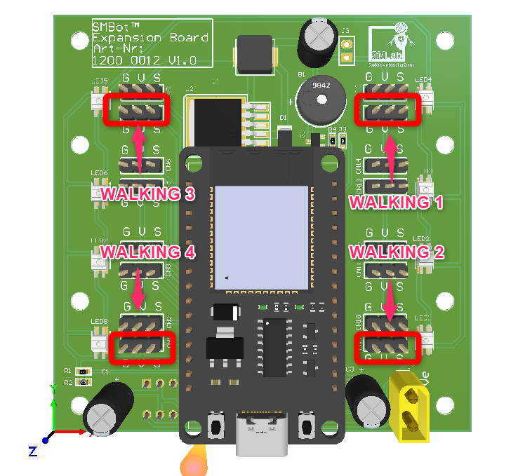Figure 8: SMLab iCrab’s Walking legs

### 2.2.3 Battery Connector & RGB Led

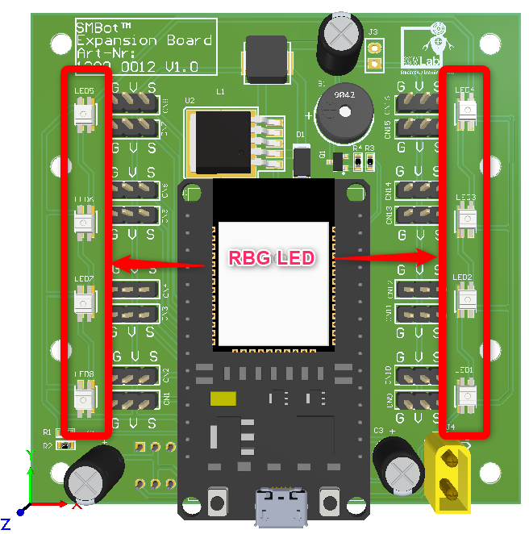Figure 9: Battery connector & RGB led

The figure above showing Battery Connector and RGB Led. Battery connector is for battery to connect to provide power supply. The RBG led is SK6812MINI. It is a smart LD control circuit and light emitting circuit in one controller LED source. It able to display any color base on the combination of red , blue and green.

### 2.2.4 Switch

The figure below showing the switch .It is a latching switch. It able to cut of the battery supply.

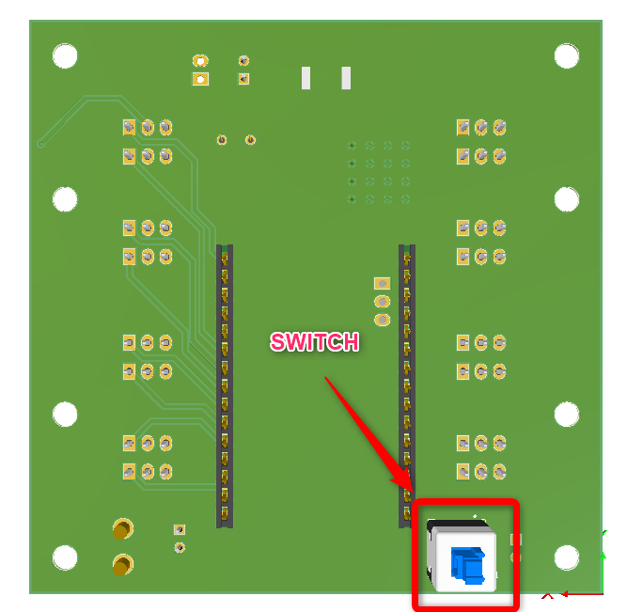Figure 10: Battery Switch

### 2.2.5 MT3608 step-up converter

MT3608 step up converter circuit. It able to convert lithium battery voltage ( 3.7v ) to 5v.

The figure below is showing the MT3608 step converter circuit.

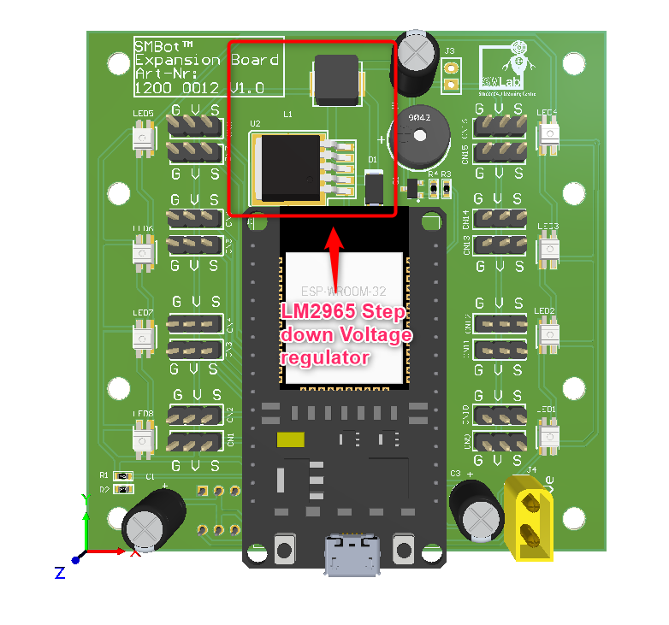Figure 11: MT3608 Step-up Converter circuit

The figure below is showing the schematic of MT3608 step up converter circuit

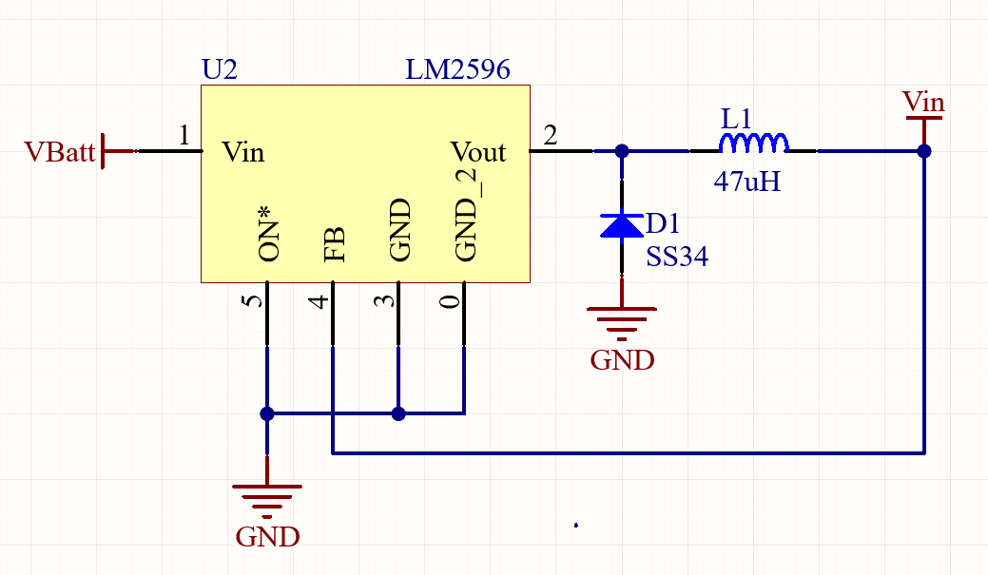

Figure 12: Schematic of MT3608 step up converter

### 2.2.5 Buzzer

The figur below showing the buzzer. It is a passive buzzer that able to have different tone with change the frequency of the PWM signal.

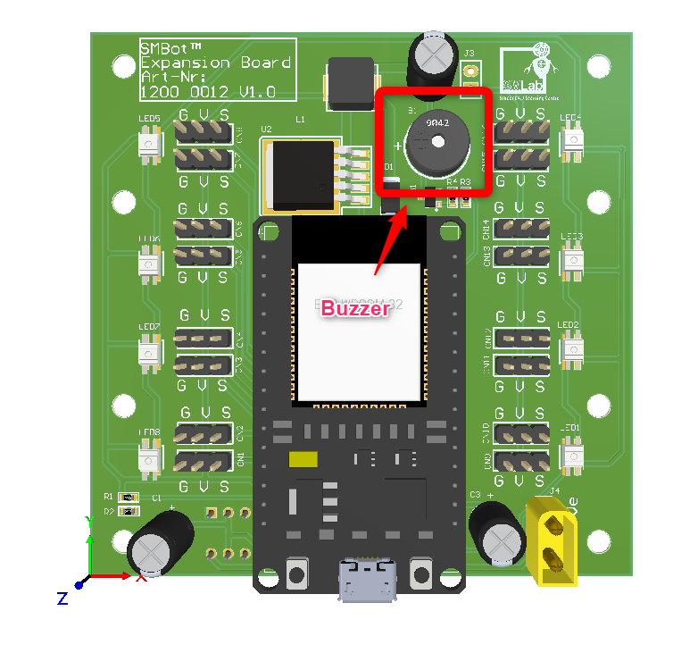Figure 13: Buzzer

### 2.2.6 Capacitor and resistor

The figure below showing capacitor and resistor

The C1 is an electrolytic capacitor is a capacitor that uses an oxide film made of aluminum, tantalum or other oxidizable metal as a dielectric. The parameter of C1 is 10v 470uF . The C2 and C3 is a ceramic capacitor where the ceramic material acts as the dielectric The paramter of C2 and C3 are 25v 22uF. In this case capacitor is to prevent voltage drip and stablize the voltage.

The resistor R1 and R2 is acting as a voltage divider for ESP32 to measure the voltage of Battery through ADC. The value of R1 and R2 are 10k and 2k . We have to use resistor because ESP32 have a 12 bit ADC which only able to measure 0 to 3.3v ( 0 – 4095 ) . We add resistor to limit the current and also the voltage in order not to burn the esp32. The figure below is showin capacitors and resistors.

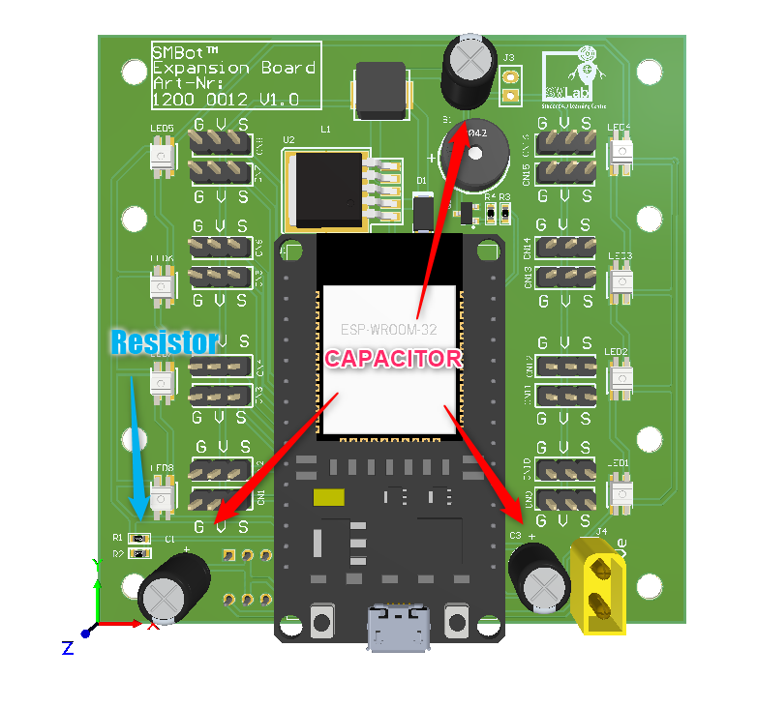Figure 14: Capacitor and resistor

# 2.3 Bom list

* iSEB Expansion Bo*ard 1200 0012 V1.0 with ESP32 Module x 1*

# *TATTU 11.1V 3S 450mAh 75C LiPo Battery Pack with XT30 Plug*

* *ESP32-DEVKIT-V1 x 1*
* *Crab chassis set x 1*

# 3 Firmware

The iSEB Expansion Board 1200 0012 V1.0 is using ESP32 DevKit V1. The figure is showing the pinout of ESP32 DevKit V1.The microcontroller is esp-wroom-32 module.

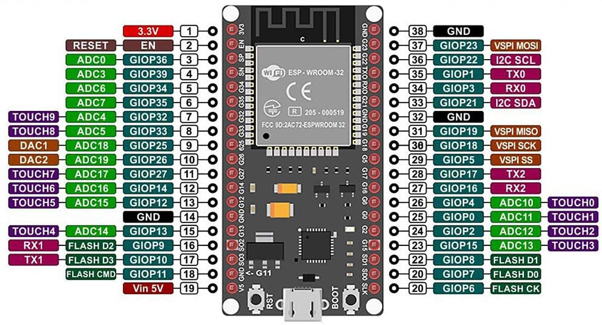Figure 15: Pinout of ESP32 DevKit V1

## 3.1 Specification of the ESP32 DevKit V1

Microcontroller: Tensilica 32-bit Single-/Dual-core CPU Xtensa LX6

* Operating Voltage: 3.3V
* Input Voltage: 7-12V
* Digital I/O Pins (DIO): 25
* Analog Input Pins (ADC): 6
* Analog Outputs Pins (DAC): 2
* UARTs: 3
* SPIs: 2
* I2Cs: 3
* Flash Memory: 4 MB
* SRAM: 520 KB
* Clock Speed: 240 Mhz
* Wi-Fi: IEEE 802.11 b/g/n/e/i:
  + Integrated TR switch, balun, LNA, power amplifier and matching network
  + WEP or WPA/WPA2 authentication, or open networks
* Dimensions: 51.5x29x5mm

## 3.2 Environment set up

We need to set up the environment to flash the binary to ESP32 DevKit V1.

* Install Arduino IDE is requried to install. ( Snapshot is base on Arduino IDE 2.2.0 )
* Add <https://raw.githubusercontent.com/espressif/arduino-esp32/gh-pages/package_esp32_index.json> to Board Managers and install ESP32 libary.
  + The figure below showing how to update board managers

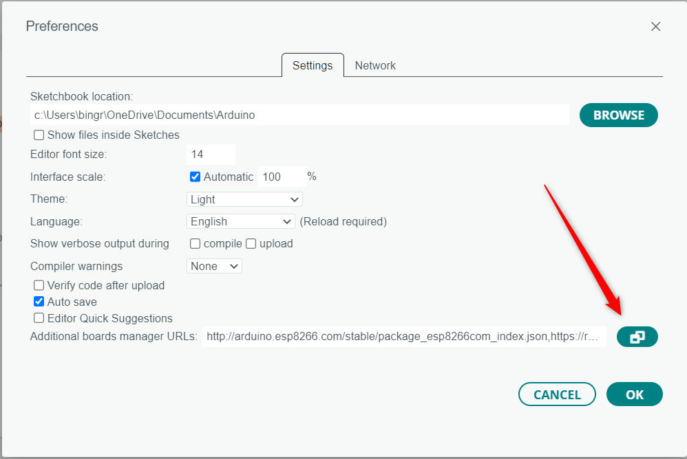Figure 16: File -> Preferences and click on the icon

* + The figure showing after adding the Boards Manager URLs

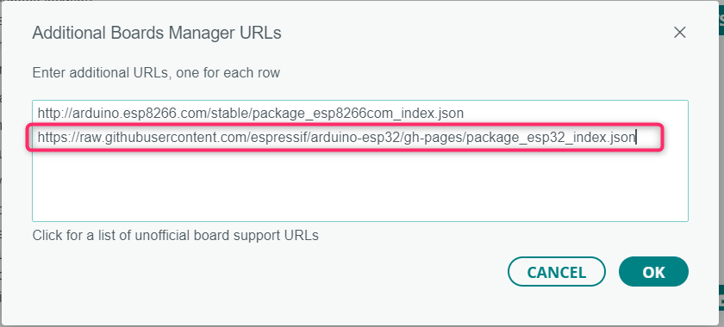Figure 17: Adding board manager URLS

* + The figure below showing how to install ESP32 by Espressif Systems at Board Manager.

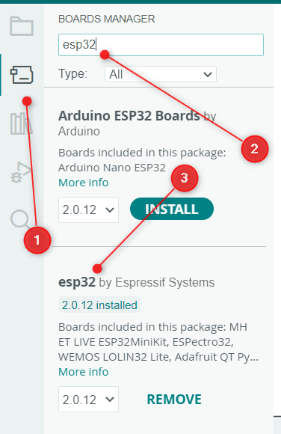Figure 18: Install ESp32 by Espressif Systems at Board Managers

* + Install WS2812FX by Harm Aldick ( version 1.4.2 ) library.
  + The figure below showing how to install WS2812FX libary

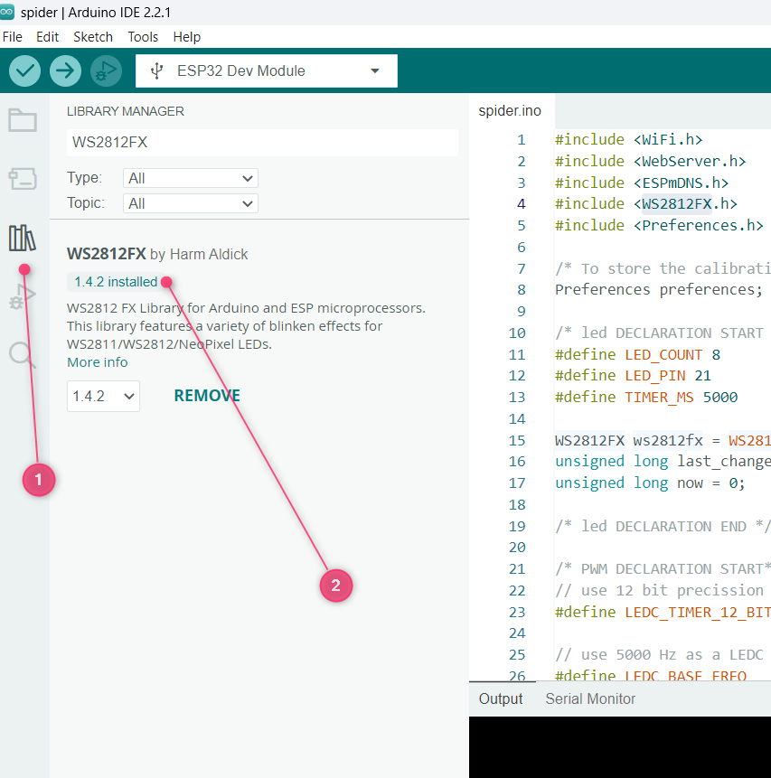Figure 19: Instal WS2812FX library

* The figure below showing how to update the upload setting

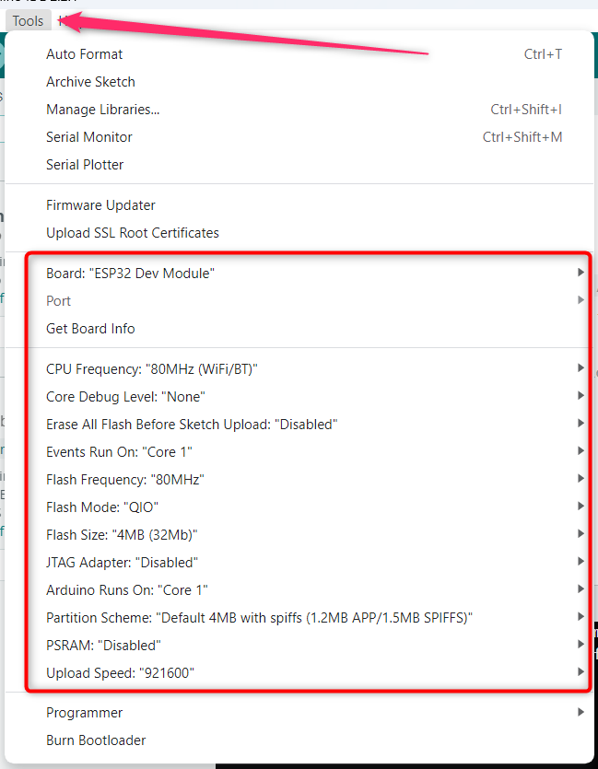Figure 20: Upload setting

* Click upload button and the firmware will be flashed successfully if the snapshot below is seen.
* The figure below showing how to compile and upload the firmwrae

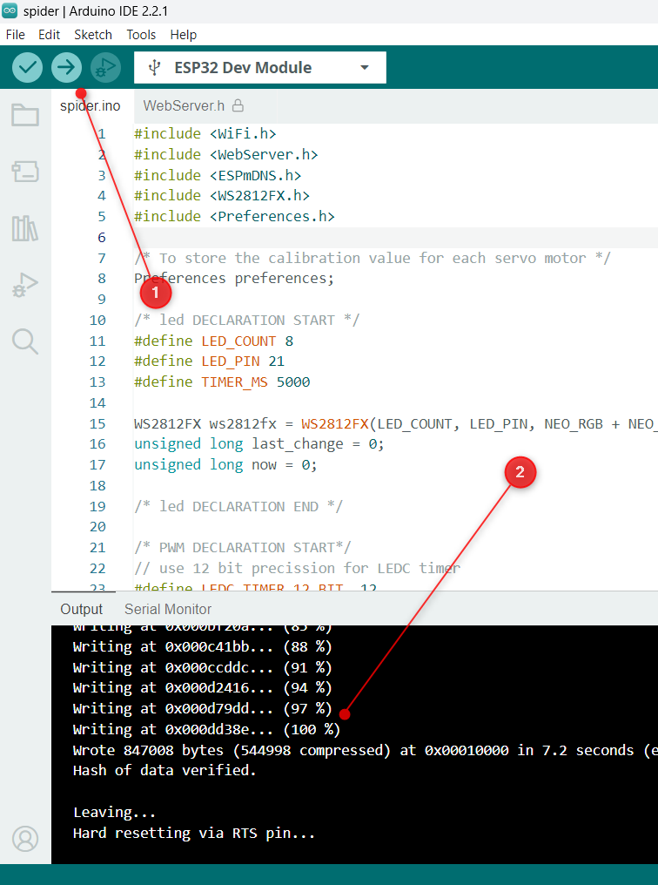Figure 21: Compile and upload

* The environment set up is done if the binary able to flash to ESP32 DevKit V1

## 3.3 WiFi

### 3.3.1 How the WiFi Code works

* Firstly we need to include WiFi and WebServer library
  + #include <WiFi.h>
    - WiFi.h - esp32 Wifi support.
  + #include <WebServer.h>
    - WebServer.h - Dead simple web-server. Supports only one simultaneous client, knows how to handle GET and POST.
* Secondly we need to insert our ssid and password
  + const char* ssid = "iSEB Crab";  // Enter SSID here
  + const char* password = "12345678";  //Enter Password here
* Then we set our web server to port 80
  + WebServer server(80);
* We have to setup the WiFi in setup function
  + To start the Wi-Fi as an Access Point.
    - WiFi.softAP(ssid);/* without password */
    - WiFi.softAP(ssid,password);/* with password */
  + Function used to configure the IP as static (fixed) as well as the gateway and subnet.
    - WiFi.softAPConfig(local_ip, gateway, subnet); /* to add exception to server */
  + Set up handling of web page
    - server.on("/",handleIndex);
    - server.on("/editor", handleEditor);
    - server.on("/controller", handleController);
    - server.on("/zero", handleZero);
    - server.on("/setting",handleSetting);
    - server.on("/save", handleSave);
  + Enable the server
    - server.begin();
* We have to handle the user request in loop funtion
  + - server.handleClient();

### 3.3.2 WiFi server and control UI

* After flash succesfully, the iSEB Crab should be appear in the WiFi list. The figure below is showing the iSEB Crab is appeared in the WiFi list.

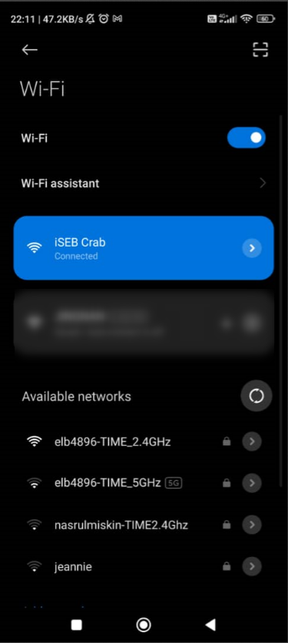Figure 22: WiFi List

* The figure below showing how to access ISEB Crab through web broswer

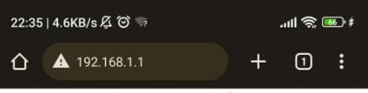Figure 23: Access ISEB Crab through web broswer

* The figure below is showing control page

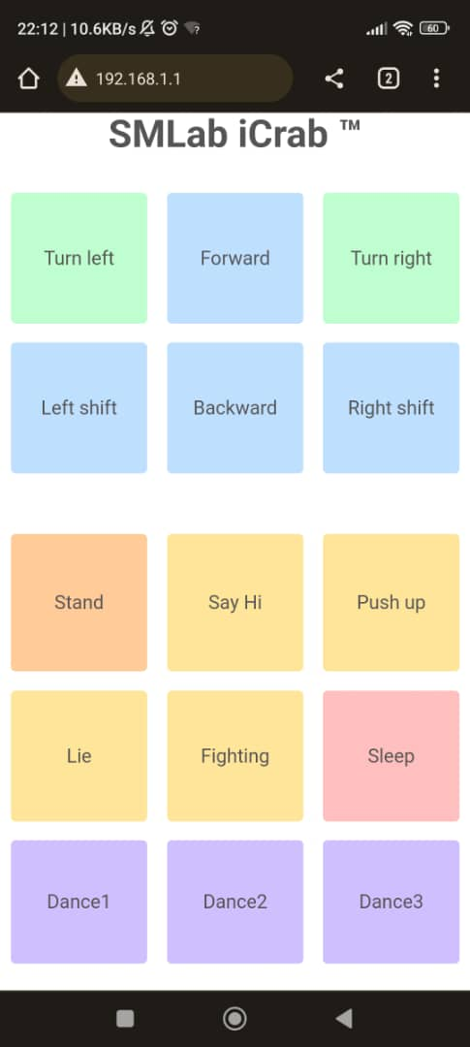Figure 24: Control Page

* The figure below is showing Motion Editor Page

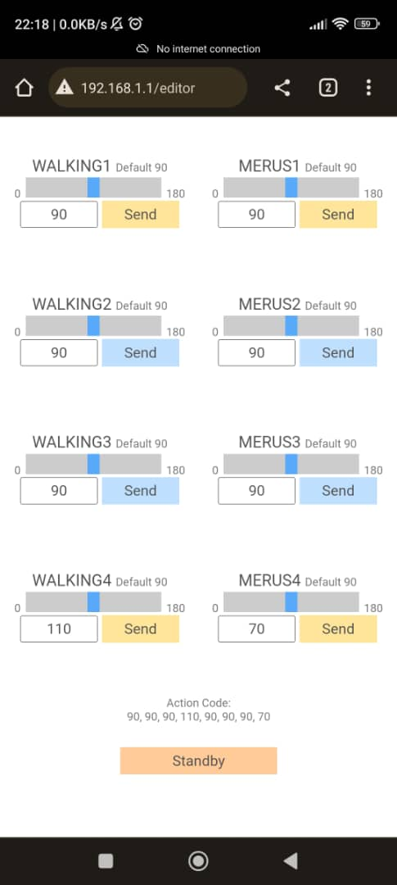Figure 25: Motion Editor Page

* The figue below is showing Zero Page

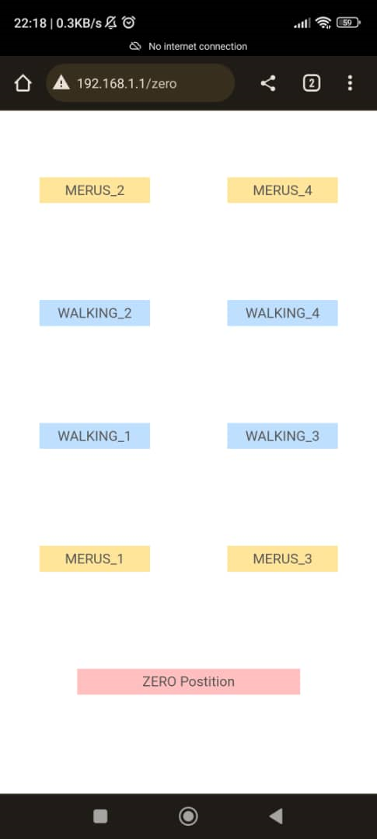Figure 26: Zero Page

* The figure below is shwoing Setting page

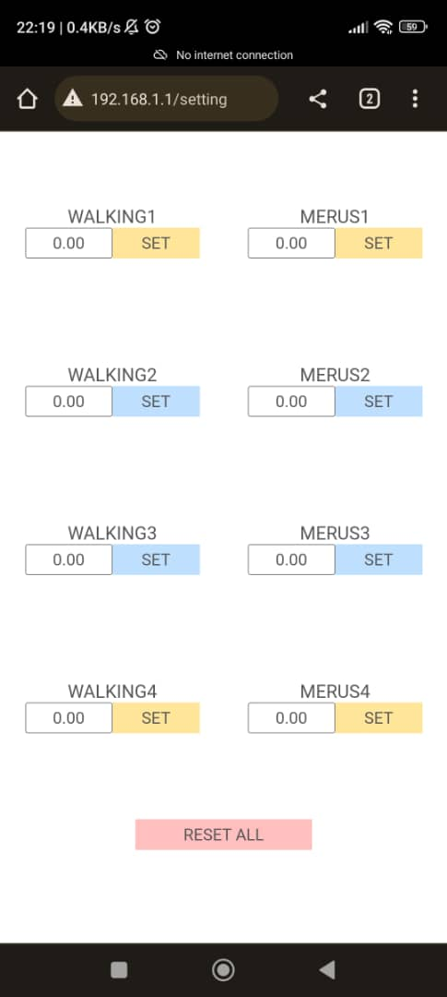Figure 27: setting page

## 3.4 Servo Motor

* The servo motor used in the iSEB Crab is TowerPro SG90 servo .
* The wire colors are Red = Battery(+) Brown = Battery(-) Orange = Signal
* The figure below show how the servo motor angle control by pwm
* Servo motor control with 50 Hz pulse width modulated (PWM) signal, which produces a pulse every 20ms.

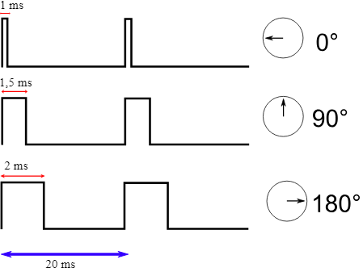Figure 28: How servo’s position controlled by PWM signal

### 3.4.1 How the Servo Motor Code works

#### 3.4.1.1 Setup

* We are using the LED Control library from ESP32 hal library to control servo motor.
* The LED control (LEDC) peripheral is primarly designed to control the intensity of LEDs, although it can also be used to generate PWM signals for other purposes. .
* For more details of the LEDC library can refer to the link
  + https://espressif-docs.readthedocs-hosted.com/projects/arduino-esp32/en/latest/api/ledc.html
* We able to generate PWM signals to control the servo motor.
* We have a motorInit funciton in the setup function to call the setup.
* We are calling funcition ledcSetupledc and ledcAttachPin in function motorInit.
* Function ledcSetupledc is used to setup the LEDC channel frequency and resolution.
  + uint32_t ledcSetup(uint8_t channel, uint32_t freq, uint8_t resolution_bits);
    - channel select LEDC channel to config.
      * ESP32 have 16 channels
    - freq select frequency of pwm.
    - resolution_bits select resolution for ledc channel.
      * range is 1-14 bits (1-20 bits for ESP32)
* Function ledcAttachPin is used to attach the pin to the LEDC channel.
  + void ledcAttachPin(uint8_t pin, uint8_t chan);
    - pin select GPIO pin.
    - chan select LEDC channel.
* The follow table is showing the GPIO vs Channel vs Connector in the example code

|  |  |  |  |
| --- | --- | --- | --- |
| **Walking/Merus** | **GPIO** | **Channel** | **Connector** |
| WALKING1 | 19 | 1 | CN15 |
| WALKING1 | 15 | 2 | CN9 |
| WALKING1 | 33 | 3 | CN7 |
| WALKING1 | 13 | 4 | CN1 |
| MERUS1 | 23 | 5 | CN16 |
| MERUS2 | 4 | 6 | CN10 |
| MERUS3 | 32 | 7 | CN8 |
| MERUS4 | 12 | 8 | CN2 |

Table 2: Position vs GPIO vs Channel vs Connector matrix

#### 3.4.1.2 Code of motorInit function

// use 12 bit precission for LEDC timer

#define LEDC_TIMER_12_BIT  12

// use 50 Hz as a LEDC base frequency

#define LEDC_BASE_FREQ     50

#define WALKING_1 0 /* Chanel 0 */

#define WALKING_2 1 /* Chanel 1 */

#define WALKING_3 2 /* Chanel 2 */

#define WALKING_4 3 /* Chanel 3 */

#define MERUS_1 4 /* Chanel 4 */

#define MERUS_2 5 /* Chanel 5 */

#define MERUS_3 6 /* Chanel 6 */

#define MERUS_4 7 /* Chanel 7 */

void motorInit()

{

  // Setup timer

  ledcSetup(WALKING_1, LEDC_BASE_FREQ, LEDC_TIMER_12_BIT);

  ledcSetup(WALKING_2, LEDC_BASE_FREQ, LEDC_TIMER_12_BIT);

  ledcSetup(WALKING_3, LEDC_BASE_FREQ, LEDC_TIMER_12_BIT);

  ledcSetup(WALKING_4, LEDC_BASE_FREQ, LEDC_TIMER_12_BIT);

  ledcSetup(MERUS_1, LEDC_BASE_FREQ, LEDC_TIMER_12_BIT);

  ledcSetup(MERUS_2, LEDC_BASE_FREQ, LEDC_TIMER_12_BIT);

  ledcSetup(MERUS_3, LEDC_BASE_FREQ, LEDC_TIMER_12_BIT);

  ledcSetup(MERUS_4, LEDC_BASE_FREQ, LEDC_TIMER_12_BIT);

  // Attach timer to a led pin

  ledcAttachPin(19, WALKING_1);  /* WALKING_1 *//* CN15 *//* PIN 19*/

  ledcAttachPin(15, WALKING_2);  /* WALKING_2 *//* CN9  *//* PIN 15*/

  ledcAttachPin(33, WALKING_3);  /* WALKING_3 *//* CN7  *//* PIN 33*/

  ledcAttachPin(13, WALKING_4);  /* WALKING_4*//* CN1  *//* PIN 13*/

  ledcAttachPin(23, MERUS_1);  /* MERUS_1 *//* CN16 *//* PIN 23*/

  ledcAttachPin( 4, MERUS_2);  /* MERUS_2 *//* CN10 *//* PIN  4*/

  ledcAttachPin(32, MERUS_3);  /* MERUS_3 *//* CN8  *//* PIN 32*/

  ledcAttachPin(12, MERUS_4);  /* MERUS_4 *//* CN2  *//* PIN 12*/

  delay(50);

}

* From the code above we have set up pwm channel 0 to 7 to 50hz frequeny with resolution 12 bit with function ledcSetup
* We have assign GPIO pin to the pwm channel accordingly with function ledcAttachPin.

#### 3.4.1.3 Update duty cycle during runtime

* ESP32 will output pwm signal after we configure the frequenc , resolutoin to the pwm channel and assign the GPIO pin to each pwm channel.
* We can call LEDCWrite to update the duty cycle of the particular pwm channel.
* By updating duty cycle we can control the positoin of servo motor mention chalter 3.4
* Functoin ledcWrite is used to set duty for the LEDC channel.
  + void ledcWrite(uint8_t chan, uint32_t duty);
    - chan select the LEDC channel for writing duty.
    - duty select duty to be set for selected channel.
* In the example code, we have set the resolution bit to 12 bit hence there are 4095 steps for the reoslution.
* By calculation we set 409 to acheive 1ms duty cycle and 819 to achieve 2ms duty cycle.
* However the example we set min to 50 min and maximum to 550 due to base on testing the servo motor only react between 50 and 550 ( will further investigate on this issue suspect is due to servo motor but yet to confirm with scope ).
* For the servo postion array such as Servo_Prg_X, the position is store as position therefore a positoin convert to duty cycle is needed.
* Function Set_PWM_to_Servo is to convert the position to duty cycle and update to the pwm channel
  + void Set_PWM_to_Servo(int iServo, int iValue)
    - iServo select the LEDC channel for writing duty.
    - Ivalue select the position to convert to duty tobe set for selected channel.

#### 3.4.1.4 Set_PWM_to_Servo

/* MOTOR CODE START */

void Set_PWM_to_Servo(int iServo, int iValue)

{

  Serial.print(F("iServo: "));

  Serial.print(iServo);

  Serial.print(F(" iValue: "));

  Serial.println(iValue);

  // Read from EEPROM to fix zero error reading

  iValue = (iValue*MAX/180.0)+MIN; /* convertion to pwm value */

  double NewPWM = iValue + preferences.getDouble((String(iServo)).c_str(),0);

  /* 0 = zero degree 550 = 180 degree*/

  ledcWrite(iServo,NewPWM);

}

* We have printed the input parameter iServo and iValue for debug purpose.
* We have do conversion for iValue from position to duty cycle
* We have done the zero error calibration but currently not in use the value will always be zero.
* We will udpate the pwm channel value with ledcWrite.